Practical No. 09

Q.no.1.

Code:-

# --------- Arithmetic Associative Law--------

print("=== Arithmetic Associative Law ===")

a = int(input("Enter value for a : "))

b = int(input("Enter value for b : "))

c = int(input("Enter value for c : "))

lhs_add = (a + b) + c

rhs_add = a + (b + c)

print(f"(a + b) + c = ({a} + {b}) + {c} = {lhs_add}")

print(f"a + (b + c) = {a} + ({b} + {c}) = {rhs_add}")

if lhs_add == rhs_add:

print("Addition Associative Law holds ")

else:

print("Addition Associative Law does not hold ")

lhs_mul = (a * b) * c

rhs_mul = a * (b * c)

print(f"(a * b) * c = ({a} * {b}) * {c} = {lhs_mul}")

print(f"a * (b * c) = {a} * ({b} * {c}) = {rhs_mul}")

if lhs_mul == rhs_mul:

print("Multiplication Associative Law holds ")

else:

print("Multiplication Associative Law does not hold ")

print("\n")

# --------- Boolean Associative Law--------

print("=== Boolean Associative Law ===")

A = bool(int(input("Enter value for a : ")))

B = bool(int(input("Enter value for b : ")))

C = bool(int(input("Enter value for c : ")))

lhs_or = (A or B) or C

rhs_or = A or (B or C)

print(f"(A or B) or C = ({A} or {B}) or {C} = {lhs_or}")

print(f"A or (B or C) = {A} or ({B} or {C}) = {rhs_or}")

if lhs_or == rhs_or:

print("OR Associative Law holds ")

else:

print("OR Associative Law does not hold ")

lhs_and = (A and B) and C

rhs_and = A and (B and C)

print(f"(A and B) and C = ({A} and {B}) and {C} = {lhs_and}")

print(f"A and (B and C) = {A} and ({B} and {C}) = {rhs_and}")

if lhs_and == rhs_and:

print("AND Associative Law holds ")

else:

print("AND Associative Law does not hold ")

print("\n")

Output:-

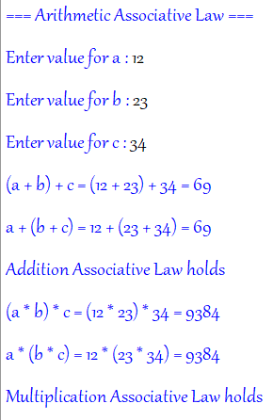

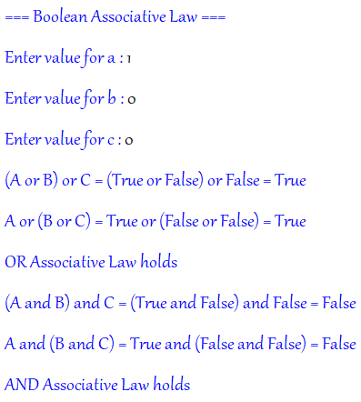

Q.no.2

Code:-

# --------- Arithmetic Distributed Law--------

print("=== Arithmetic Distributed Law ===")

a = int(input("Enter value for a : "))

b = int(input("Enter value for b : "))

c = int(input("Enter value for c : "))

lhs = a * (b + c)

rhs = (a * b) + (a * c)

print(f"LHS = {a} * ({b} + {c}) = {lhs}")

print(f"RHS = ({a} * {b}) + ({a} * {c}) = {rhs}")

if lhs == rhs:

print("Distributed Law holds for Arithmetic!\n ")

else:

print("Not Equal")

print("--------------------------------------------------")

# --------- Boolean Distributed Law--------

print("=== Boolean Distributed Law ===")

A = bool(int(input("Enter value for a : ")))

B = bool(int(input("Enter value for b : ")))

C = bool(int(input("Enter value for c : ")))

lhs_bool = (A and B) or C

rhs_bool = (A and B) or (A and C)

print(f"LHS = ({A} and {B}) or {C} = {lhs_bool}")

print(f"RHS = ({A} and {B}) or ({A} and {C}) = {rhs_bool}")

if lhs_bool == rhs_bool:

print("Distributed Law holds for Boolean logic!\n ")

else:

print("Not Equal ")

Output:-

